SIMATS ENGINEERING
ASSESSMENT TOOL 1
Experiments

COURSE NAME: Computer Networks COURSE CODE: CSA07
COURSE OUTCOME COVERED
CO3: Analyze the performance of core network protocols such as TCP, UDP, HTTP,
and DNS under varying conditions
Assessment Tool Weightage: 40%
SOFTWARE: CISCO PACKET TRACER, WIRESHARK

EXPERIMENTS

QUESTIONS:4 Total Marks:40
1. Design a simple LAN consisting of two PCs connected through a switch using
Cisco Packet Tracer. Configure appropriate IP addresses for both hosts and
verify connectivity using the ping command. Simultaneously capture the packet
exchange using Wireshark. Identify the Ethernet frame fields such as Source
MAC Address, Destination MAC Address, EtherType, and Frame Check
Sequence (FCS). Explain how the Data Link layer uses MAC addressing to
ensure successful frame delivery within the local network.
2. Create a network topology consisting of two LANs connected through a router
in Cisco Packet Tracer. Configure IPv4 addressing, subnet masks, and default
gateways for all devices, and verify end-to-end communication using the ping
command. Capture the ICMP packets using Wireshark and analyze the IPv4
header fields, including Source IP Address, Destination IP Address, Time-To-
Live (TTL), Protocol Number, and Header Length. Explain the role of the
Network layer in forwarding packets between different networks.
3. Construct a local area network with multiple hosts connected through a switch in
Cisco Packet Tracer. Clear the ARP cache on one of the hosts and initiate
communication with another host using the ping command. Capture the
communication in Wireshark and identify the ARP Request and ARP Reply
packets. Analyze the sender and target MAC/IP addresses and explain how the
Address Resolution Protocol resolves logical IP addresses into physical MAC
addresses before data transmission.
4. Develop a simple network consisting of two PCs connected through a router in
Cisco Packet Tracer. Configure the required IP addresses and test connectivity
using the ping command. Capture the ICMP traffic using Wireshark and identify
the Echo Request and Echo Reply messages. Examine important ICMP fields
such as Type, Code, Identifier, and Sequence Number, and calculate the Round
Trip Time (RTT). Discuss how ICMP assists in network troubleshooting and
connectivity verification.
5. Create a client-server network in Cisco Packet Tracer by configuring a web
server and a client PC. Enable the HTTP service on the server and access the
hosted webpage from the client using a web browser. Capture the
communication in Wireshark and identify the TCP three-way handshake,
followed by the HTTP GET request and HTTP response messages. Analyze the
application-layer communication and explain how TCP provides reliable
delivery for HTTP traffic through connection establishment, acknowledgments,
and ordered data transfer.

RUBRICS FOR CALCULATION

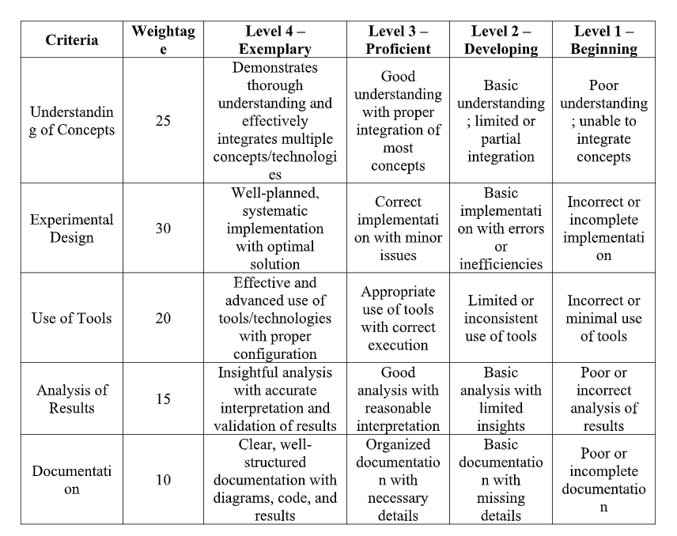

QUESTION 1
Topology
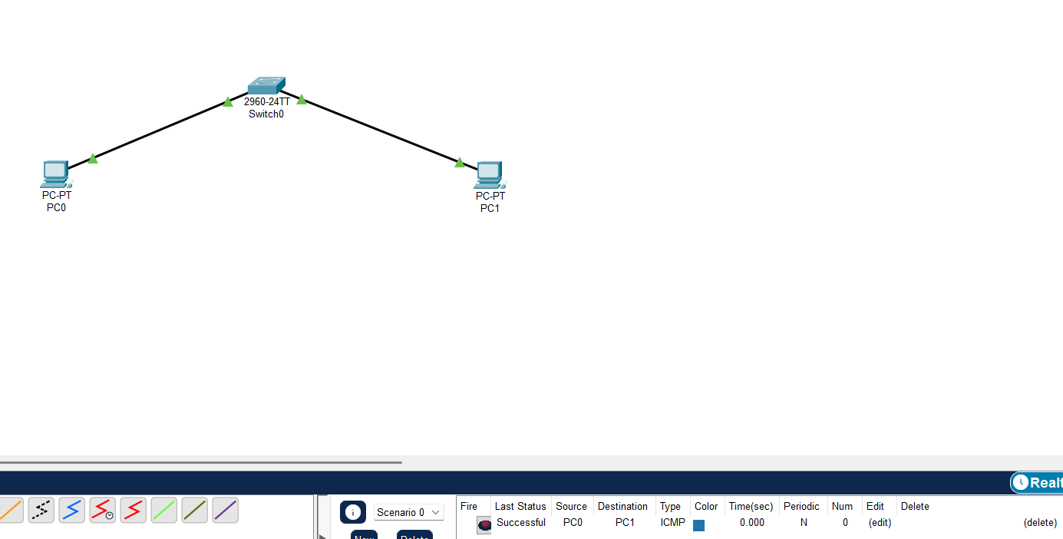
IP Address

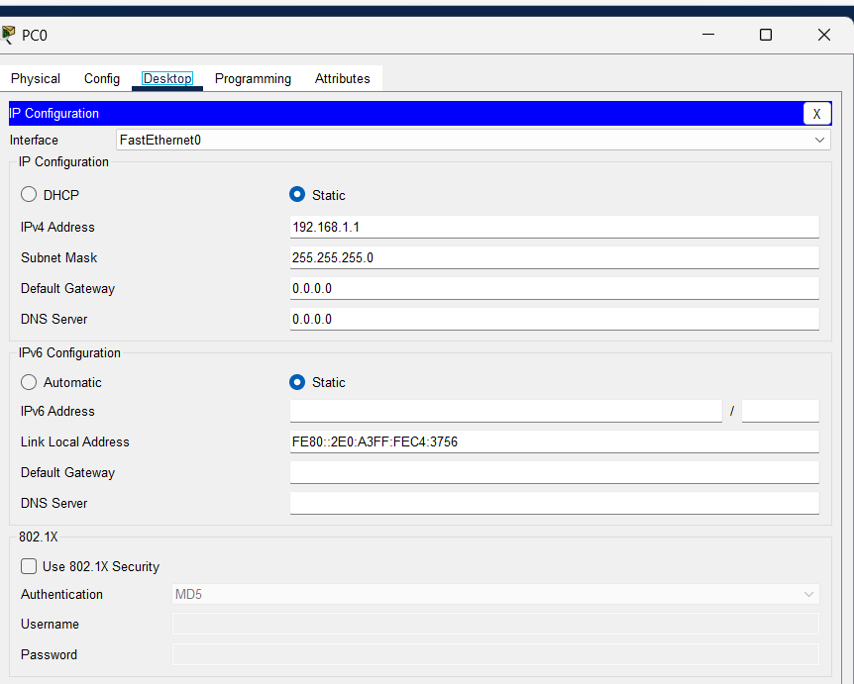
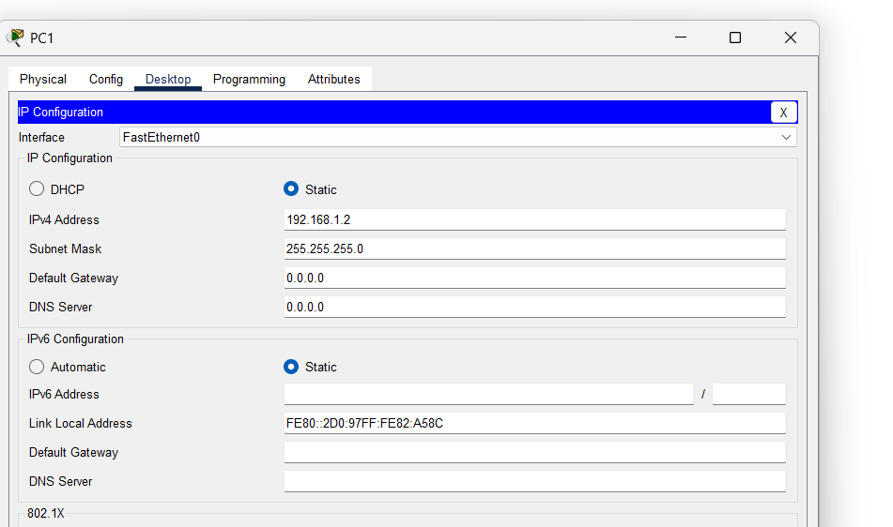

SIMULATION
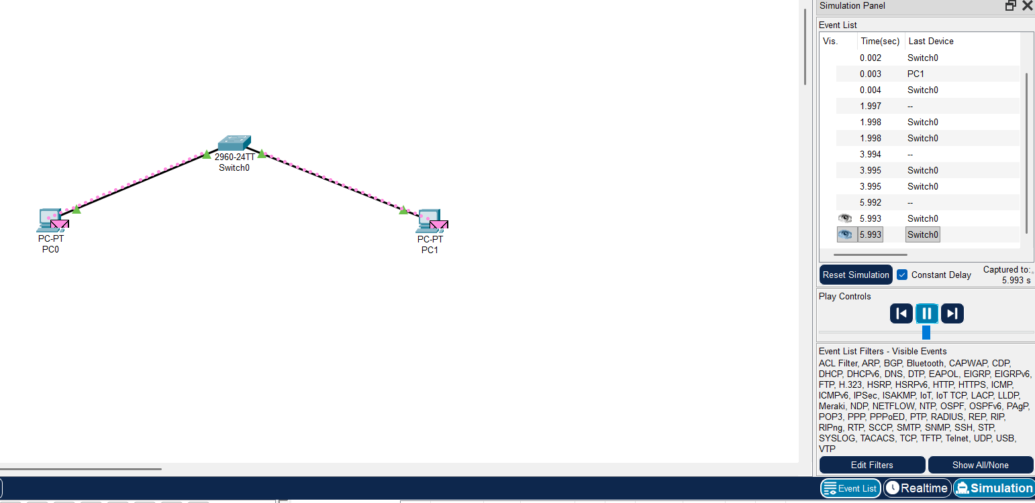

2,SIMULATION:
